
Foundation University Islamabad
School of Science and Technology

Name: Hunaina Yasir Roll Number: 073
Subject: PF LAB Section: B
LAB NO.1
( EXPERIMENT – INTRODUCTION TO DEV C++ IDE )
Dev-C++ is a full-featured Integrated Development Environment (IDE) for the C/C++ programming language. Like similar IDEs, it offers the programmer a simple and unified tool to edit, compile, link, and debug programs. It also provides support for the management of the files of a program in “projects” containing all the elements required to produce a final executable program.
Dev-C++ is a Free Software distributed under the terms of the GNU General Public License (GPL). The IDE can be downloaded here:

https://bloodshed-dev-c.en.softonic.com/download

Dev-C++ can be installed on any Windows machine with Windows XP/7/8/10. This tutorial uses Dev-C++ 5.11 on Windows 10 (configuration in the computer labs as of course 2016-2017). For the sake of simplicity, use the default installation options in your home computer.
The application development process encompasses the following steps:
- Create a project/source file

The type of application and the programming language to be used are specified
- Write source code

Write the program in C++ and save the source code file.
- Compile and link the code

The source code is compiled and linked to generate a running program. Other files of the project may be created if required.
- Fix compilation errors if any

If the syntax of the program is not correct, the compilation fails and the compiler generates a message related to the error/s. The programmer must correct the errors.
- Run the program

Run the program to validate the functioning.
- Fix execution errors if any

If the actions performed by the program are not as expected, it is necessary to correct the source code. It may be also convenient to use the debugger to find complex errors.
Start Dev C++
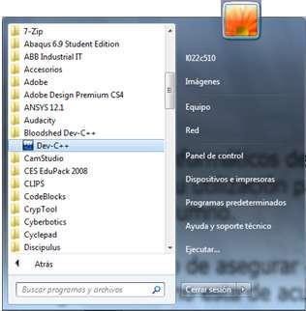
Start the IDE from the Program folder Dev-C++ or Bloodshed Dev-C++.

Figure 1. Running Dev-C++ in the computer lab
Create a Source File
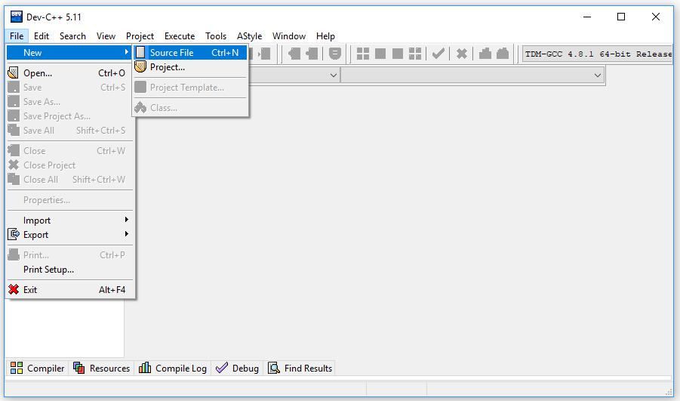
The source code will be written in a file called the source code file. It is necessary to create a source code file by using the menu (File > New > Source File).

Figure 2. Creating a new source code file
The IDE generates a basic source code file (by default, Untitled1.cpp). These files are not saved in the project folder until the programmer saves or compiles the program (see below).
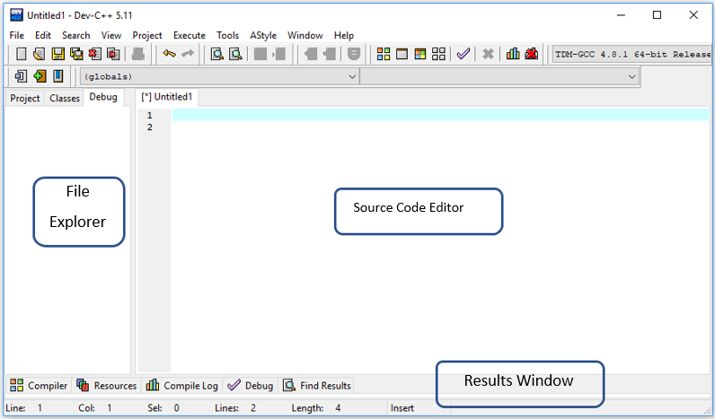

Figure 3. Three sub-windows in IDE
The IDE window includes three sub-windows: the Project Files Explorer, the Result Tabs, and the Source Code Editor. These windows can be resized and minimized.
The Files Explorer window shows the name of the project and the included files. The Project tab usually contains a single file with the source code of the program. In this pane, we can find two additional tabs: Classes and Debug. The classes tab shows the functions of the program. The debug tab shows watched variables in the debugging process.
The Results window is used to present the results of the actions of the IDE: compilation errors, compiling directives, debugging commands, etc.
Writing Source Code
Once the Source File has been created, we can start writing our C++ program.
It is recommended to use the classic color configuration of the editor (Tools > Editor Options > Syntax > Color Speed Settings > Classic) and to activate the support for opening and closing brackets (Tools > Editor options > General > Highlight matching braces/parenthesis).
The editor highlights with different colors keywords and other elements of the C++ language. The classic scheme uses:
- Light blue for comments

- Green for included libraries.

- Red for text strings
- Bold black for C++ keywords
For instance, the HelloWorld program is shown as follows:
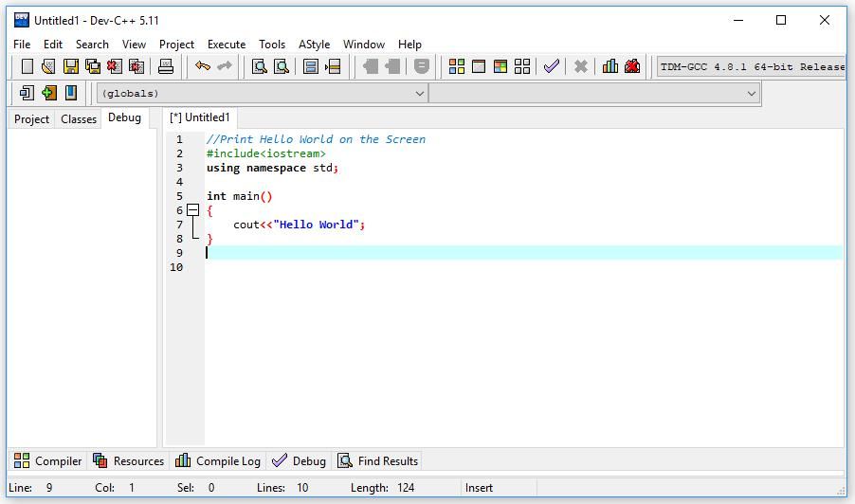

Figure 4. The HelloWorld program.
Compilation and Link
To run a program, the source code must be compiled and linked. Dev-C++ performs the complete process by clicking the Compile button or from the menu (Execute > Compile or pressing the F9 key).
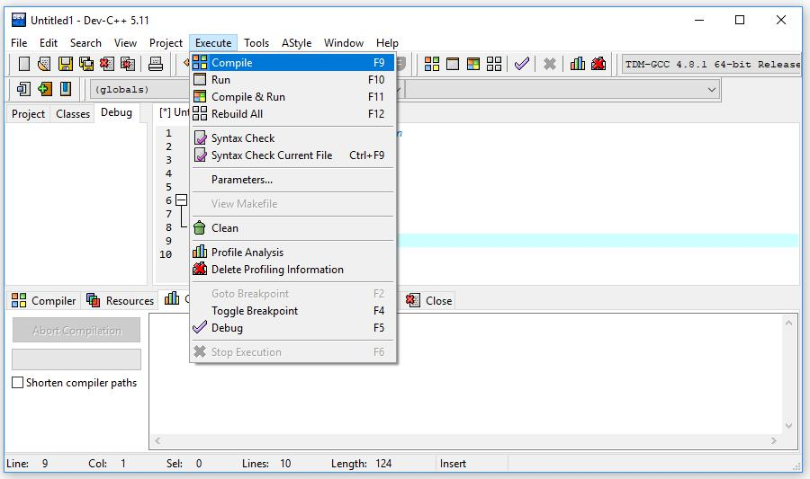

Compile Button

Figure 5. Compiling the source code
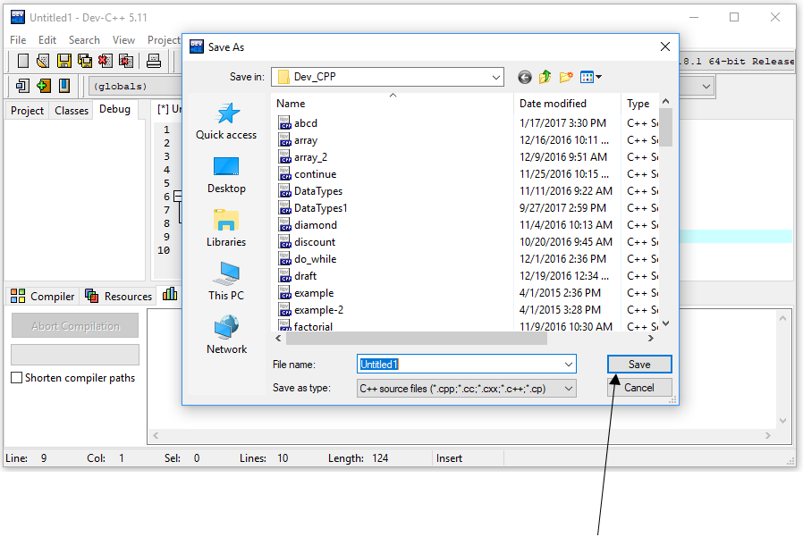
The editor displays the File Save Dialogue Box to save the file before compilation and execution as shown.

Figure 6. Save the source code file.
Select the appropriate folder and specify the filename. Then click Save to store the file permanently on the local drive. Once the compilation process is finished successfully the log will be displayed in the Results Window as shown.
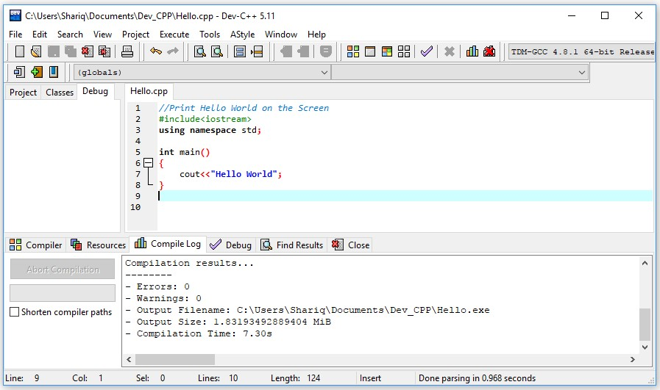
Figure 7. Compilation successful as shown in the Compile Log window.

Execute the Program 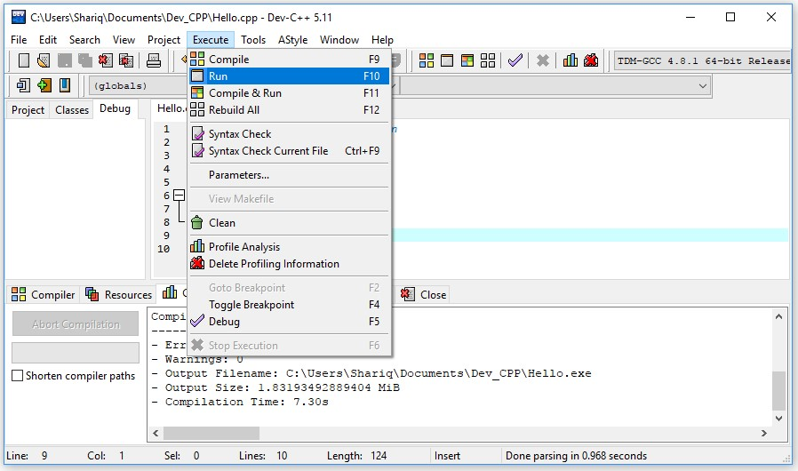
Then execute/run the program by clicking

Run button or from menu (Execute > Run
or pressing F10 key).

Figure

8
.
Executing the program

It is possible to compile and run the program in a single step by clicking Compile & Run button or from menu (Execute > Compile & Run or pressing F11 key).

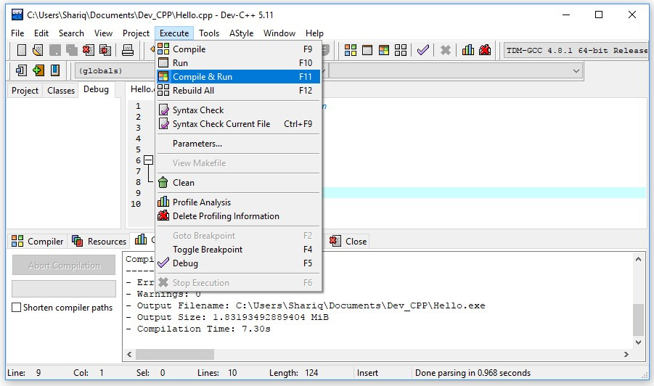
Figure 9. Compile and Run in one-step
Assuming you did not make any syntax errors on your code, you should see a similar output window running your program.

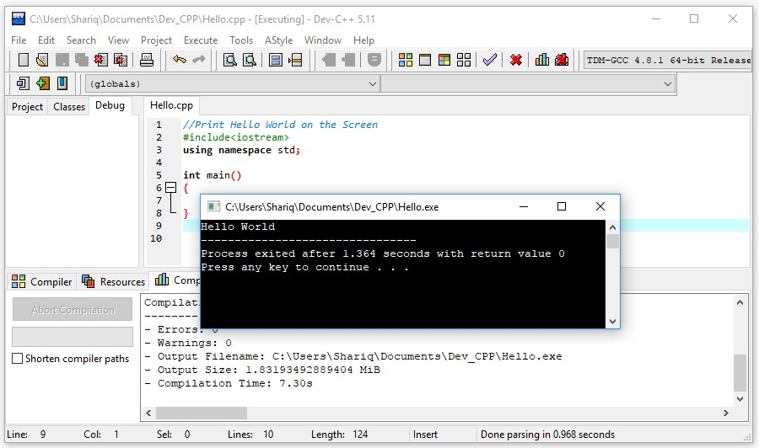
Figure 10. Displaying the output window

